Estimating Capacity and Velocity

Writing this after we had worked out to use One week sprints only. That is, after the first two sprints or first three weeks of the presentation, we worked out we only had 6 one week sprints left so we could work out the high and low velocity for the overall project:

* 6\*23=128 Low velocity
* 6\*29=174 high velocity

Velocity review of each sprint:

Sprint 1:

This was the very first time we used taiga and assigned point to all of the tasks so the point assigned are not accurate to the time they took to complete or the effort put in. we completed all of the tasks but finished very early on in the week.

Estimated: 55

Actual: 50

Velocity: 50

Sprint 2:

This was the week we experimented with a two week sprint, we gave everyone more work todo overall. From the burndown chart il looks like a more uniform decent and so could imply like more work it worked more effectively. we ultimately decided against using the two week sprint as we felt like the one week sprint allowed us to meet more and reflect more on what we had done in that week.

Estimated :70

Actual:70

Velocity:70

Sprint 3:

This sprint no points were assigned to any tasks, a human error so i cannot analyze the velocity

Estimated: 0

Actual: 0

Velocity: 0

Sprint 4:

This sprint no points were assigned to any tasks, a human error so i cannot analyze the velocity

Estimated:0

Actual:0

Velocity:0

Sprint 5:

Sprint 5 was the next one where we assigned points, looking at the burndown chart, we can see that not everything was completed at the end of the sprint. this is indicative that too much work assigned that week. In reality it was just that no one had moved there tasks to closed before the sprint date ended which ended up in the graph looking disproportionate to what actually happened

Estimated: 230

Actual: 180

Velocity: 180

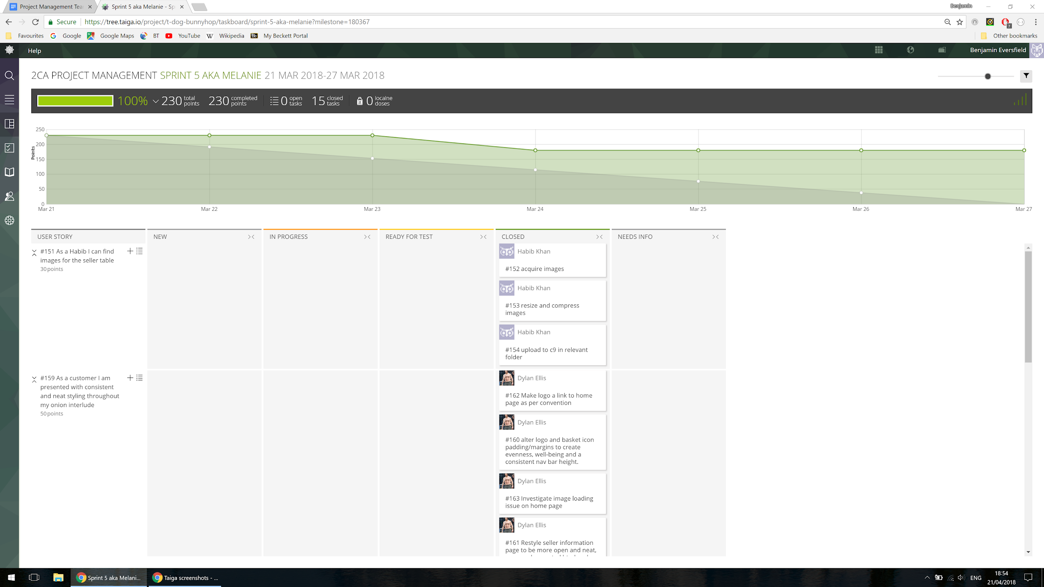

Sprint 6:

Again we ended with tasks not closed so the chart runs on to next week, this was again due to human error and so tasks didn't get done. this resulted in a lower velocity than expected. This was corrected in the last two sprints. Also the value assigned to each task is disproportionate to the other sprints

Estimated: 50

Actual: 23

Velocity: 23

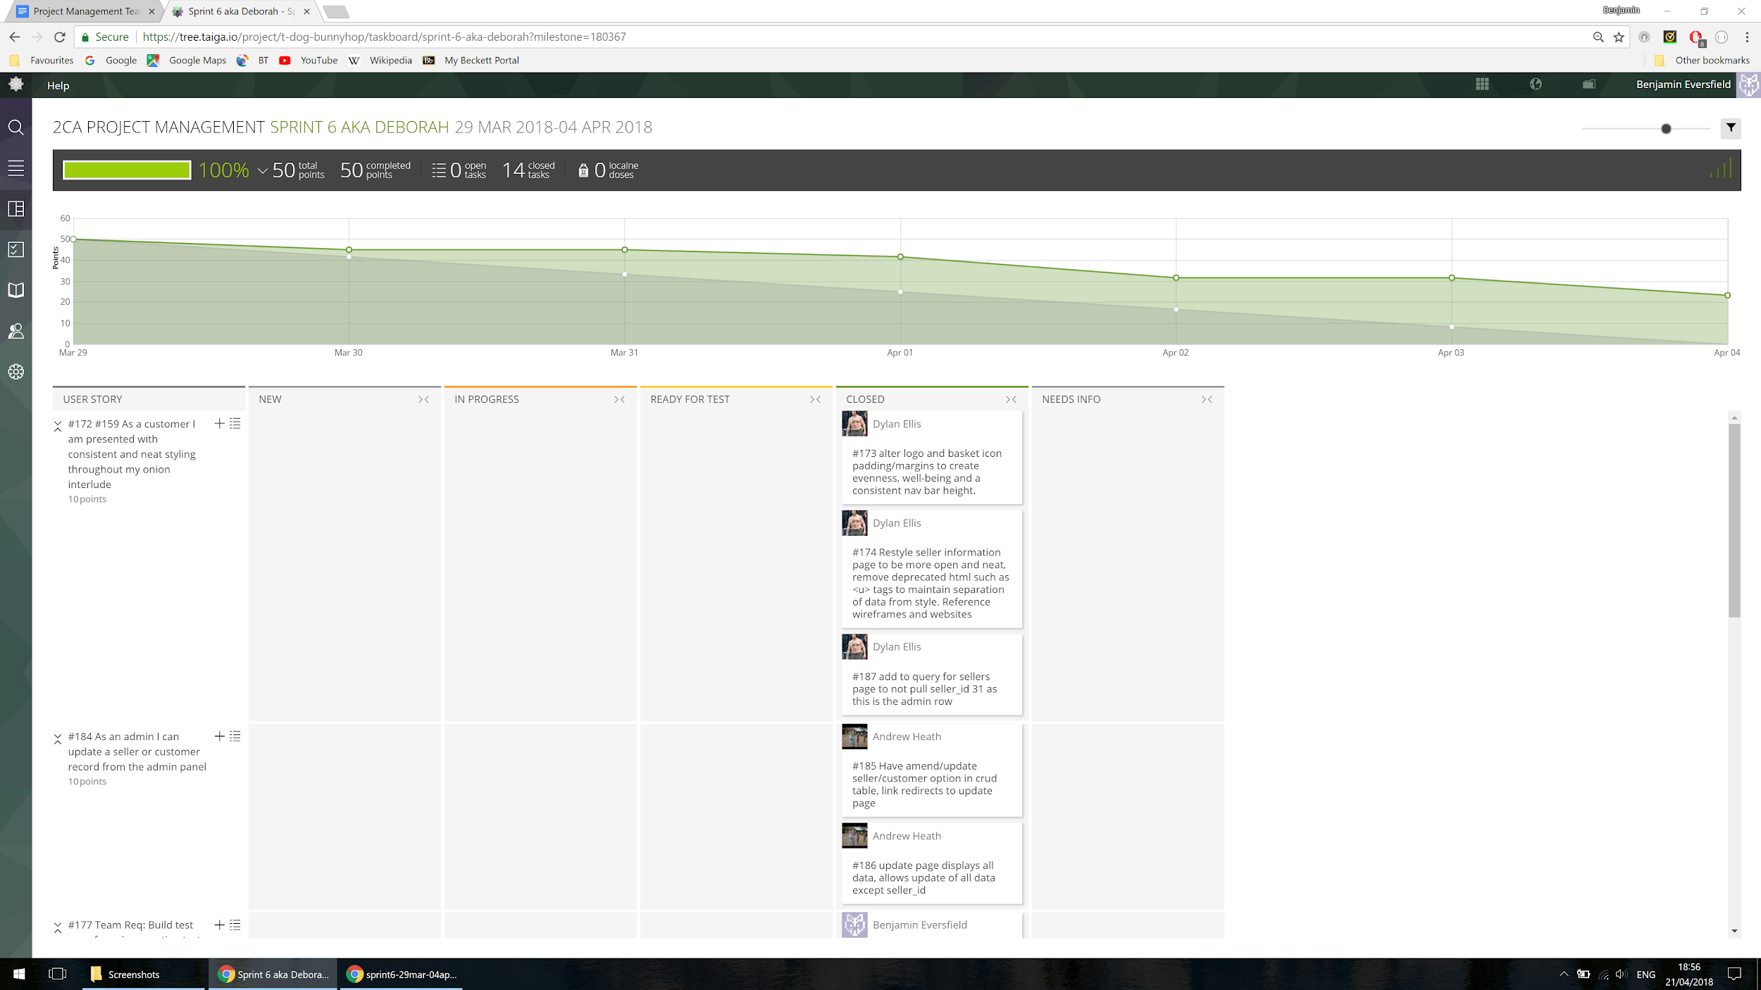

Sprint 7:

This is when we were headed to the wned of the project so a lot of tasks took longer to complete, but were completed in the sprint.

Estimated: 50

Actual: 50

Velocity: 50

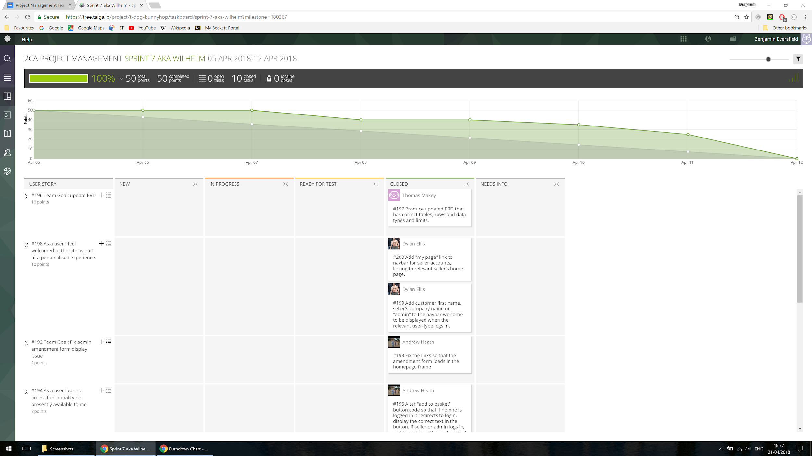

Sprint 8:

This was the final sprint and so we tried to finish strong, we finished our work early in the week, giving us a high velocity for the last week.

Estimated: 29

Actual:29

Velocity:29

